Supplementary Materials
- Phone sensor features used in the analysis
No.Order in the dataset | name | Category
1 | acc min magnitude | Movement
2 | acc max magnitude | Movement
3 | acc mean magnitude | Movement
4 | acc median magnitude | Movement
5 | acc std magnitude | Movement
6 | length of charge minutes | Battery
7 | num rows battery | Battery
8 | avg call duration | Device usage
9 | std call duration | Device usage
10 | min call duration | Device usage
11 | max call duration | Device usage
12 | total call duration | Device usage
13 | number rows calls | Device usage
14 | number incoming calls | Device usage
15 | number missed calls | Device usage
16 | number of correspondents phone | Device usage
17 | number outgoing calls | Device usage
18 | number rows messages | Device usage
19 | number of outgoing messages | Device usage
20 | number of incoming messages | Device usage
21 | number of correspondents | Device usage
22 | location variance | Location
23 | location variance log | Location
24 | total distance meters | Location
25 | speed mean meters per sec | Location
26 | speed var meters per sec | Location
27 | location entropy | Location
28 | location entropy normalized | Location
29 | max len stay at clusters in minutes | Location
30 | mean len stay at clusters in minutes | Location
31 | min len stay at clusters in minutes | Location
32 | std len stay at clusters in minutes | Location
33 | moving time percent | Location
34 | number location transitions | Location
35 | radius of gyration | Location
36 | number of clusters | Location
37 | time at cluster 1 | Location
38 | time at cluster 1 in group | Location
39 | time at cluster 2 | Location
40 | time at cluster 2 in group | Location
41 | time at cluster 3 | Location
42 | time at cluster 3 in group | Location
43 | unlocks per minute | Device usage
44 | number of minutes interaction | Device usage
45 | number of minutes unlock | Device usage
46 | max len minute interaction bout | Device usage
47 | min len minute interaction bout | Device usage
48 | mean len minute interaction bout | Device usage
49 | std len minute interaction bout | Device usage
50 | max len minute unlock bout | Device usage
51 | min len minute unlock bout | Device usage
52 | mean len minute unlock bout | Device usage
53 | std len minute unlock bout | Device usage
54 | time of day | Time/Day
55 | avg latitude | Location
56 | avg longitude | Location
57 | med latitude | Location
58 | med longitude | Location
59 | std latitude | Location
60 | std longitude | Location
61 | WTSD latitude | Location
62 | WTSD longitude | Location
63 | max latitude | Location
64 | max longitude | Location
65 | min latitude | Location
66 | min longitude | Location
67 | total distance | Location
68 | speed mean sec | Location
69 | moving time | Location
70 | number location | Location

- Features Description
Category | Features selected by Random Forest | Description &  Implementation details | Ref.
TIME | Time of day | The time at which this entry occurred (0-23 hours).  Calculate what time the data is located based on the timestamp | [17]
LOC | max latitude  med latitude  min latitude  avg latitude  std latitude  max longitude  med longitude  min longitude  avg longitude  std longitude | Statistics of latitude and longitude within the time window  1) Remove noise records, select location records  2) Calculate maximum, minimum, median, mean, and standard deviation | [43]
LOC | Radius of gyration | The radius of gyration of all valid transition locations within the time window  1) Remove noise records (where location label==-1), select location records where location label changes from previous records as "transition locations";  2) Mathematically, the radius of gyration here is the root mean square distance of all transition locations from the center of them;  Calculated as follows:  sqrt(((lat1-lat mean)^2+(lon1-lon mean)^2+(lat2-lat mean)^2+(lon2-lon mean)^2+......)/num transitions) | [17]
LOC | number location | Locations passed by participants within the time window  1) Remove noise records, select location records  2) Calculate the duration interval between two data  3) Calculate the distance between two data  4) Calculate the speed between two data by duration and distance  5) If speed >0.3m/s, we identify the second data as the moving point  6) If a participant moves from the previous data as a moving point and the following data as a stationary point, we assume that the person moves to another place. number location add 1. | Self-developed
LOC | speed mean sec | Average speed of participants within the time window  1) Remove noise records, select location records  2) Calculate the speed  Calculated as follows:  total distance/moving time | [17]
LOC | weighted stationary latitude  weighted stationary longitude | The variation of the locations the participants visited within the time window  1) Remove noise records, select location records  2) Calculate the duration interval between two data  3) Calculate the distance between two data  4) Calculate the speed between two data by duration and distance  5) If speed >0.3m/s, we identify the second data as the moving point  6) To calculate standard deviation by considering the time spent at each location  Calculated as follows:  sqrt(cov(latitude, duration)  sqrt(cov(longitude, duration) | [43]
LOC | total distance | The total distance moved by the participant within the time window  1) Remove noise records, select location records  2) Calculate the duration interval between two data  3) Calculate the distance between two data  4) Calculate the speed between two data by duration and distance  5) If speed >0.3m/s, we identify the second data as the moving point  6) Calculate the total distance of all moving points within the time window | Adopted by [43] and created
LOC | moving time | Time for participants to move within the time window  1) Remove noise records, select location records  2) Calculate the duration interval between two data  3) Calculate the distance between two data  4) Calculate the speed between two data by duration and distance  5) If speed >0.3m/s, we identify the second data as the moving point  6) Calculate the total time of all moving points within the time window | Adopted by [43] and created
MOV | acc median magnitude  acc mean magnitude  acc max magnitude  acc min magnitude  acc std magnitude | The median, mean, maximum, minimum, and standard deviation phone accelerate the magnitude of the participant within the time window | [17]
BAT | num rows battery | The number of cell phone battery data generated within the time window | [17]
DEV | unlocks per minute | The number of times participants unlock their phones per minute within the time window. | [17]
DEV | mean len minute interaction bout  min len minute interaction bout  max len minute interaction bout | Average, minimum, and maximum interaction time between a participant and screen within the time window | [17]
DEV | number of minutes interaction | The total number of interactions between a participant and screen within the time window | [17]
DEV | mean length minute unlock bout | Average time for unlocking the phone within the time window | [17]
LOC: location, MOV: movement, BAT: battery usage, DEV: device usage
The time window refers to a 15-minutes, a unit of analysis in our study
Max=maximum, min=minimum, med=median, len=length, acc=acceleration, std=standard deviation, sec=second, avg=average, num=number, m=meter, s=second, sqrt=square root, cov= covariance, lat=latitude, lon=longitude
- Extra Analysis with Rounded Location Data
To protect the privacy of the participants, we do not disclose granular location data, We keep latitude and longitude data to one decimal place.
We report the models with a 1-hour prediction distance and different amounts of phone sensor data (1-, 3-, 6- 9- and 12-hour windows) for Weekday. Comparing the performance of models using phone sensor data with different amounts of phone sensor data (e.g., 1-, 3-, 6-, 9-, 12-hours) for the same prediction distance (e.g., 1-hour), we found that 9 hours of phone sensor data achieved the best model for Weekdays.
Table c-1. Performance of the models with different “Analysis Window" (amount of sensor data analyzed) for Weekdays in predicting Non-Drinking, Low-Risk Drinking and Binge Drinking Event (BDE) 1 hour in advance
Model | WDXGBoost -W1D1 | WDXGBoost -W3D1 | WDXGBoost -W6D1 | WDXGBoost -W9D1 | WD XGBoost -W12D1
Accuracy | 66.7% | 81.1% | 85.2% | 87.4% | 85.8%
F1 | 0.67 | 0.81 | 0.85 | 0.87 | 0.86
Kappa | 0.15 | 0.53 | 0.65 | 0.71 | 0.69
BDE Precision | 0.33 | 0.70 | 0.81 | 0.88 | 0.81
BDE Recall | 0.22 | 0.73 | 0.67 | 0.71 | 0.64
BDE F1 | 0.27 | 0.71 | 0.76 | 0.79 | 0.72
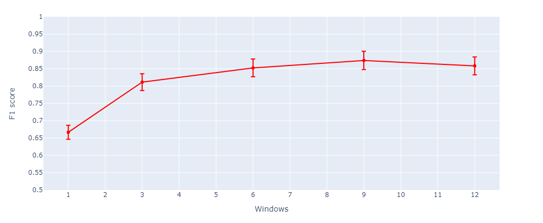
Figure c-1. WDXGBoost -W9D1 = Weekday XGBoost - Analysis Window Size = 9 hours and Prediction Distance = 1 hour from drinking onset.
We do the same for the weekend dataset, by comparing the phone sensor data with different analysis window sizes (e.g., 1-, 3-, 6-, 9-, 12-hours) for the same prediction distance (1 hour). We found that 12 hours of phone sensor data achieved the best model for Weekends.
Table c-2. Performance of the models with different “Analysis Window" (amount of sensor data analyzed) for Weekend in predicting Non-Drinking, Low-Risk Drinking and Binge Drinking (BD) Event 1 hour in advance
Model | WEXGBoost -W1D1 | WEXGBoost -W3D1 | WEXGBoost -W6D1 | WEXGBoost -W9D1 | WEXGBoost -W12D1
Accuracy | 62.7% | 74.3% | 79.7% | 81.2% | 88.0%
F1 | 0.63 | 0.74 | 0.80 | 0.81 | 0.88
Kappa | 0.32 | 0.55 | 0.63 | 0.65 | 0.79
BDE Precision | 0.44 | 1.0 | 0.78 | 0.79 | 0.88
BDE Recall | 0.50 | 0.52 | 0.69 | 0.70 | 0.84
BDE F1 | 0.47 | 0.68 | 0.73 | 0.74 | 0.86
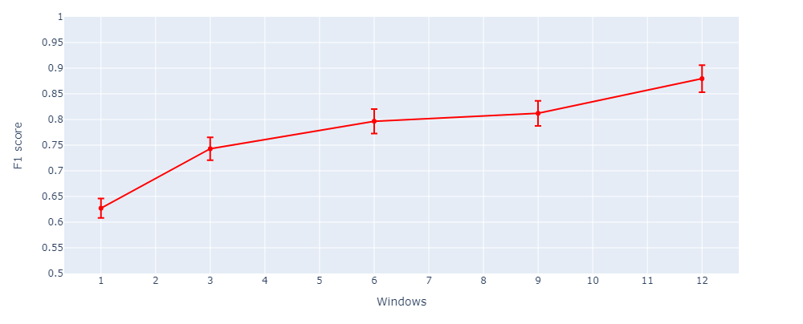
Figure c-2. WEXGBoost -W12D1 = Weekend XGBoost - Analysis Window Size = 12 hours and Prediction Distance = 1 hour from drinking onset.
For Weekdays, using the analysis window size with the best performance (9 hours), we tested models with different “prediction distances” (1-6 hours) in predicting Binge Drinking Event (BDE), Non-Drinking and Low-Risk Drinking
Table c-3 Performance of models with different “Prediction Distances” (1-6 hours before) for Weekdays in Predicting Binge Drinking Event (BDE), Non-Drinking and Low-Risk Drinking
Model | WDXGBoost -W9D1 | WDXGBoost -W9D3 | WDXGBoost -W9D6
Accuracy | 87.4% | 90.6% | 90.7%
F1 | 0.87 | 0.91 | 0.91
Kappa | 0.71 | 0.78 | 0.81
BDE Precision | 0.88 | 0.92 | 0.83
BDE Recall | 0.71 | 0.77 | 0.77
BDE F1 | 0.79 | 0.84 | 0.80

For the weekday prediction model, we found that the XGBoost model with a 9-hour analysis window and 6-hour prediction distance had the highest F1-score for predicting binge drinking events
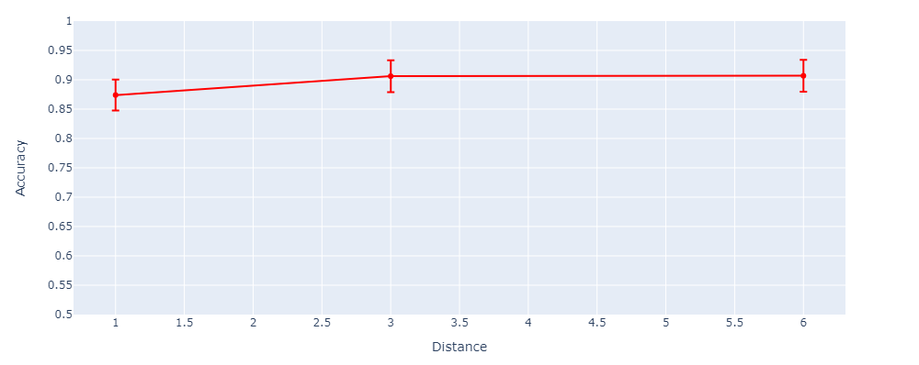
Figure c-3. Weekday XGBoost – Analysis Window Size = 9 hours and Prediction Distance = 6 hours from drinking onset.
We do the same for the weekend dataset, using the analysis window size with the best performance (12 hours), we tested models with different “prediction distances” (1-6 hours) in predicting Binge Drinking Event (BDE), Non-Drinking and Low-Risk Drinking
Table c-4. Performance of models with different “Prediction Distances" (1-6 hours before drinking onset) for Weekend in Predicting BDE, Non-Drinking and Low-Risk Drinking
Model | WEXGBoost -W12D1 | WEXGBoost -W12D3 | WEXGBoost -W12D6
Accuracy | 88.0% | 89.9% | 91.1%
F1 | 0.88 | 0.90 | 0.91
Kappa | 0.79 | 0.82 | 0.84
BDE Precision | 0.88 | 0.91 | 0.83
BDE Recall | 0.84 | 0.86 | 0.96
BDE F1 | 0.86 | 0.88 | 0.89

For the weekend prediction model, we found that the XGBoost model with a 12-hour analysis window and 6-hour prediction distance had the highest F1-score for predicting binge drinking events.
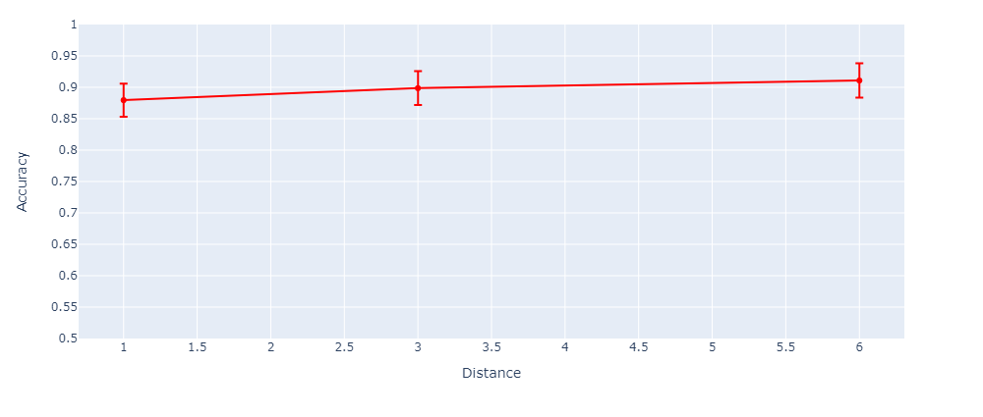
Figure c-4. Weekend XGBoost - Analysis Window Size = 12 hours and Prediction Distance = 6 hours from drinking onset.
- General areas analyzed in the Two-Way Partial Dependence Plots (PDP) (Presented in Figure 9 in the manuscript)
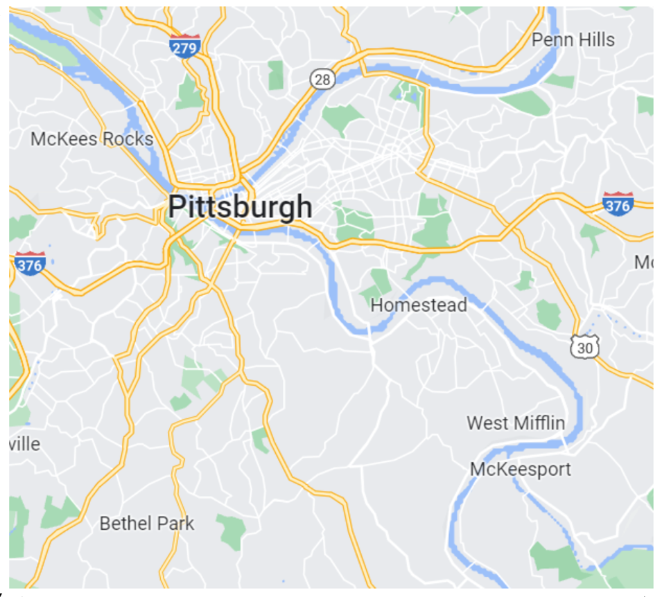
Figure D-1. General Areas in the Pittsburgh Area that the samples were collected from, analyzed in the Two Way Partial Dependence Plots
Contour plot analysis was done using the samples that fall inside the area represented in the map above for the weekdays model. Samples outside the Pittsburgh Metro Area were excluded from the analysis. Also excluded from the analysis were samples that could be classified as in Pittsburgh Metro Area, but that were spread sparsely and far away from the majority of the samples. The distribution of the samples mostly falls around the Three Rivers area.

